**Latihan DML 3**

**Update Data**

Perhatikan tabel Customers dibawah ini.

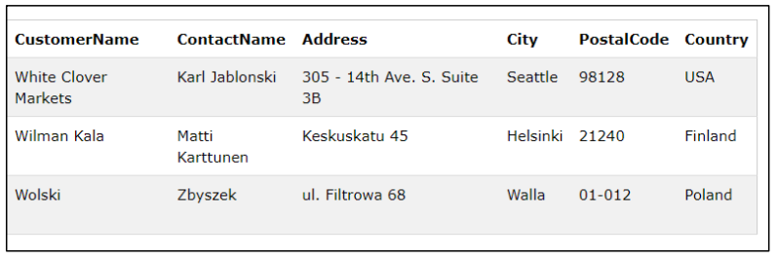

Ubahlah data customer berikut ini!

|  |  |
| --- | --- |
| **Before** | **After** |
| Wolski | Alfred |
| Walla | Frankfurt |